TENNESSEE ASSOCIATION

FFA

EAST TENNESSEE REGIONAL OFFICER

APPLICATION

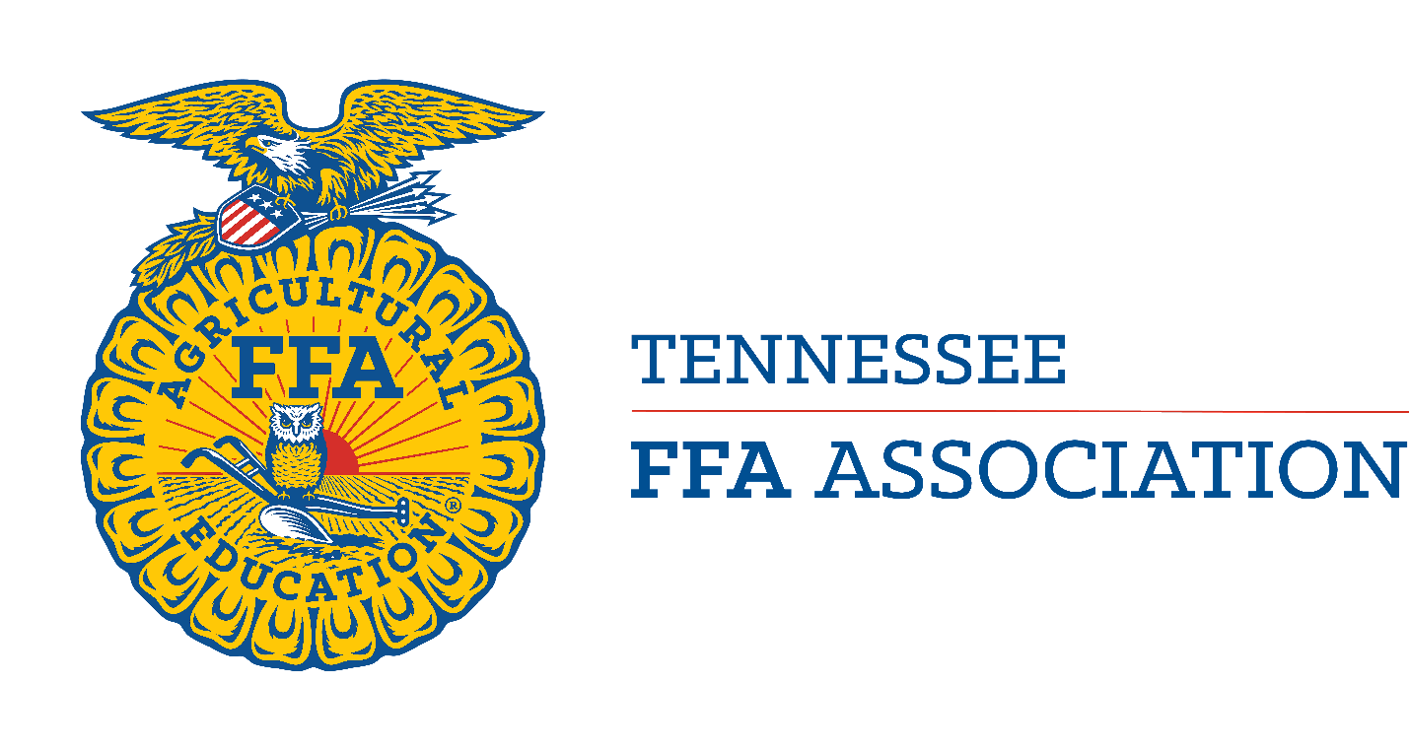

East Tennessee FFA

5295 Ottway Road

Greeneville, TN 37745

EAST TENNESSEE FFA OFFICER APPLICATION
(Please type or print)

attach
recent
photograph

Name:
(first) (middle) (last)

Chapter: Advisor(s):

High School: County:

Current grade:

School Address:

School Phone:

Home Address:

Home Phone

Cell Phone

Highest FFA Degree Held: _________________________________________________

Chapter Offices Held (Include Year): _________________________________________
________________________________________________________________________

Regional Office You Most Desire:

FFA Jacket Size: Males _____________ Females: ______________________

(If a tailored jacket is needed, then provide all measurements from a professional tailor using the form provided by National FFA. This can be found at www.ffaunlimited.org)

Polo Shirt Size: Small Medium Large X-Large XX-Large

Dress Shirt or Blouse Size: ___________ Dress Pant Size: ____________Skirt Size: ___________

Outerwear Jacket Size: ____________________T-Shirt Size _____________________________

Please answer the following questions if you are a Graduating Senior:

- Do you plan to attend a college or university this coming academic year?

- If so, which semesters will you be attending?

- If so, where will you be attending?

Regional Officer Applications are due April 2, 2024, in PDF format, emailed to Stena.Meadows@tn.gov. If you have questions concerning your application, contact Stena Meadows, East Tennessee FFA Regional Coordinator at (423) 329-0970 or via the email address above.
Regional Officer Selection will be held at The University of Tennessee at Knoxville on April 11, 2024, beginning at 5:00 PM.
Announcement of Regional Officers will be during the East Tennessee FFA Awards Banquet on April 30, 2024, at The University of Tennessee.

IF ELECTED TO EAST TENNESSEE FFA OFFICE,
I WILL:

- Be dedicated and committed to FFA and the total program of education in agriculture/agribusiness.

- Be willing to commit time to East Tennessee officer activities.

- Be willing and able to travel in serving the East Tennessee Region.

- Become knowledgeable of agriculture, of education in agriculture/agribusiness, and of FFA.

- Through preparation and practice, develop myself into an effective public speaker and project a desirable image of FFA at all times.

- Regularly and promptly write all letters, thank you notes, reports and other correspondence which are necessary and desirable.

- Strive to improve my ability to carry on meaningful and enjoyable conversations with individuals of all ages and walks of life.

- Accept and search out constructive criticism and evaluation of my total performance.

- Keep myself up to date on current events.

- Evaluate periodically my personality and attitudes, making every effort to improve myself.
- Maintain and protect my health.

12. As an East Tennessee FFA Officer I agree to also follow the state officer code of ethics:

- To forego use of all alcohol, tobacco, and drugs while involved in official or unofficial FFA activities.

- To treat all FFA members equally by not favoring one over another.

- To conduct myself in a manner which commands respect without any display of superiority.

- To maintain dignity while being personable, concerned, and interested in my contacts with others.

- To avoid places or activities which in any way would raise questions as to my moral character or conduct.

- To consider FFA officer activities as my primary responsibility.

- To use wholesome language in all occasions.

- To maintain proper dress and good grooming for all occasions.

- To work in harmony with fellow FFA officers, and not knowingly engage in conversations detrimental to other FFA members, officers, and adults.

13. Serve as a member of the team, always maintaining a cooperative attitude.

14. Be willing to take and follow instructions as directed by those responsible for me.

I have read, studied, and understood the above points. If elected to East Tennessee office, I will carry out my responsibilities in accordance with these statements and understand that I can be removed from office by the East Tennessee FFA Board of District Advisors if I have not satisfactorily followed these established standards for state officers.

_______________________________ ____________________________________
Advisor's Signature Date Candidate's Signature Date

Parent's Signature Date

Please answer the following questions pertaining to your FFA, leadership, and other activities :

What will be the scope of your SAE program next year?

Do you currently have a job or plan to get one in the next year?

If elected to an office what would be your primary means of transportation to regional

events?

What skills do you possess that would be beneficial to our Regional FFA Officer Team?

__________________________________________________________________

__________________________________________________________________

__________________________________________________________________

__________________________________________________________________

List the most important of your FFA activities and positions. Do not attach additional pages. If space is limited, list only major activities.

Year Activity Involvement
Please answer the following questions:

What is your favorite FFA Competitive Event? ________________________________________ ______________________________________________________________________________

What is your most cherished FFA memory? __________________________________________ ______________________________________________________________________________

How has FFA influenced your career plans? __________________________________________ ______________________________________________________________________________

List the most important of your school and community activities. Do not attach additional pages. If space is limited, list only major activities.

Year Activity Involvement
Express in your own words: (Maximum of one page) (typed preferred)

“Why I want to be an East Tennessee Officer”
We have carefully checked this application and find that all statements are true in every detail. We certify that records are filed with the chapter advisor supporting all activities listed, and we recommend the applicant as an East Tennessee FFA Officer candidate. We hereby permit for publicity purposes the use of any information included in this application with the exception of the following:

The following is a tentative list of regional officer activities that your student, child will be involved with if elected to office. This information is to inform students, parents and advisor what is expected of Regional Officers. Dates cannot be specific as many events have not been planned yet.

DATE | Time Involved | Activity | Location
April 30 | 1 day | East TN Regional Banquet | Knoxville
Weekly | 1 hour/week | Weekly Regional Officer Zoom
May-July TBA | 5 days | FFA Camp Clements (Regional Officer Retreat) | Camp Clements, Doyle, TN
Aug 9-10 | 3 days | Region Officer Training (ROPE) | Camp Clements
Aug 2024 | 1 day | CPC Planning | Knoxville
Sep 2024 | 1 day | Chapter Presidents Conference (CPC) | Knoxville
Sept 7 | 1 day | FFA Entries at TN Valley Fair | Knoxville
Sept 9 | 1 day | FFA Day at TN Valley Fair | Knoxville
Sept 2024 | 1 day | UT Varsity Visit Planning | Knoxville
Oct 2024 | 1day | UT Varsity Visit Planning | Knoxville
Fall 2024 | Weekend | Greenhand Conf/UT Varsity Visit | Knoxville
Nov 2024 | 2 days 1 night | FFA Leadership Series Training | Camp Clements
Dec 2024 | 1 day | Regional Officer Meeting | Knoxville
Feb 2025 | 2 days | FFA Week Activities | TBD
March 2025 | 1 day | Regional Officer Training Workshop | Knoxville
April 2025 | 2 days | ET Awards Banquet Planning | TBA
April 2025 | 1 day | ET Awards Banquet | Knoxville
Varies | 4 Activities | ET CDE’s/LDE’s | Varies

Signed
Parent or Guardian Candidate

Chapter President Chapter Advisor

SCHOLARSHIP VERIFICATION

*Grade Point Average:___________

I certify that the above GPA is correct for and that

he/she has a satisfactory scholastic record. Signed:
School Counselor

*All candidates must have at least a 2.5 grade point average to be eligible as a regional officer

* All students must furnish a copy of their high school transcript.

Supplemental Information Sheet
This page allows you to attach any information to support your candidacy for Regional Office. All materials (i.e. pictures, newspaper articles, power point slides, etc.) must fit on one page and cannot fold out.

